**Hermes**

1. The problem I am trying to solve is when I or my partners lose track of how many orders we made or did with all the information about each order, we have a mini delivery crew and serve some restaurants but have no way of tracking our orders other than manually writing them down on paper or phone, which takes time, so I want to make an application to make life easier for us or any new people we add to our crew in the future.
2. 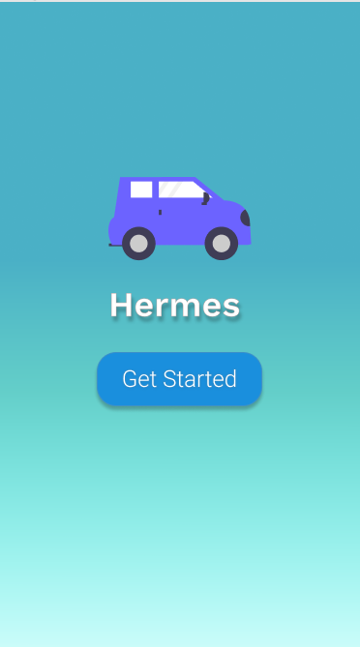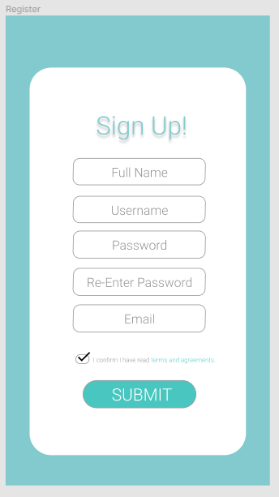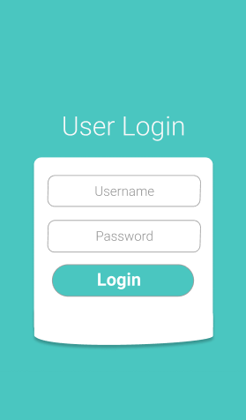Below includes the wireframes for the following activities: Landing Screen, User Registration, User login, Home dashboard, Income Log activity, Ownings Log, and the History Log. These wireframes are the initial idea produced during the design phase but can be altered during the design phase (edits such as in the theme and appearance, adding or removing a screen for speed sake as mentioned in part one, the main purpose of this app is to make things easier and faster for our delivery crew.

**1**

**2**

**3**

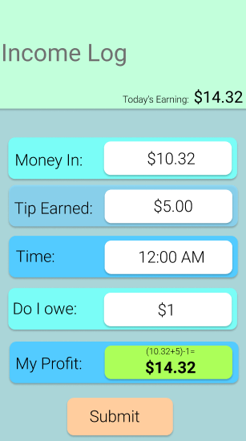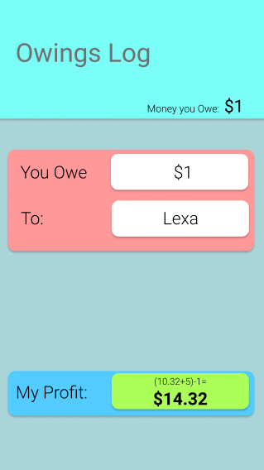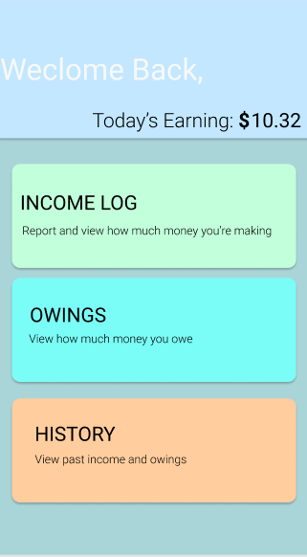

**6**

**5**

**4**

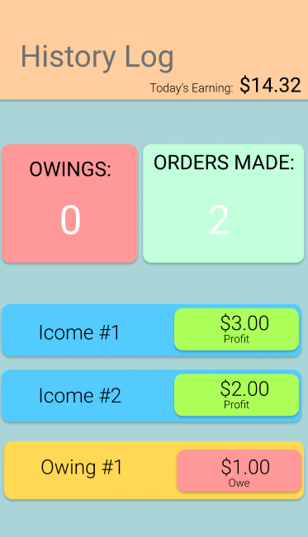

**7**

1. The flow of the application will start from number 1 as shown in the wireframe above until wireframe 7 and vice-versa. The possible intents to be used in this project include but not limited to File Storage, creating a New Note, and using an implicit intent to communicate between the registration and user login activity.
2. In the best-case scenario, I would store the calculations from the app onto local storage or SQLite. In a worst-case scenario, I would store the calculations done onto the Firebase database, it will be determined in the building phase of the project. In both cases, my datable schema will have the following table column and row attributes.

Table 1: Users (userId,name,password,email)

Table 2: History (historyId,ordersMade,ifOwe,myProfit,oweAmount)

Table 3: Income Log (logId, moneyIn,tipEarned,timeEarned,ifOwe,myProfit)

Table 4: Owings (OwingsID, oweAmount, isPaid, toWho)

The schema may have things added to it or removed from it during the building phase.

1. The Async Task in my application is having the app calculate in the background what my ***profit***is given the amount of income, possible money I owe, and possible tips I receive. The App is responsible to compute the result while I am filling in the required fields as shown in wireframe screenshot #5. When the user selects the “History Log”, the user will have to wait while obtaining a response from the postExecute() method to display the appropriate data from the Income Log to the History Log’s Owings and order made fields.
2. To save the state of the app some methods I will be using are onSaveInstanceState(), onRestoreInstanceState(), onCreate(), onDestroy() [Though if I am able to successfully not use onDestroy(), I will since its not an appropriate place for saving].

|  |  |  |  |  |  |  |  |
| --- | --- | --- | --- | --- | --- | --- | --- |
| Phase | Weeks (Week 1 starts Feb 22) | | | | | | |
| Weeks [Numbered] | W1 | W2 | W3 | W4 | W5 | W6 | W7 |
| Gathered the information I needed to make this project (Project Scope and goals) |  |  |  |  |  |  |  |
| Planning the project out, the timings, and separating each job, and designing the UI. |  |  |  |  |  |  |  |
| Developing the Login and Sign-up Functionality |  |  |  |  |  |  |  |
| Developing the Main profile/page |  |  |  |  |  |  |  |
| Syncing the application and user info with the database/host |  |  |  |  |  |  |  |
| Testing Phase |  |  |  |  |  |  |  |
| Final touches before submission |  |  |  |  |  |  |  |

Table Key: [Due – Pending – Completed – W = Week - Empty]

Week 2 – Report 1 Due / Week 5 – Report 2 Due / Week 7 – Final Submission of Project Due